34.88: We have images formed from both ends. From the first:
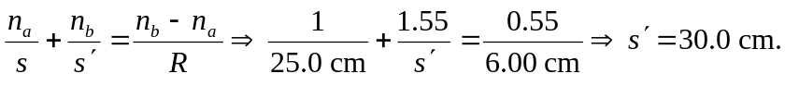
This image becomes the object for the second end:
